**Siddhant Mundhe**

**Data engineering batch 1**

**Day 19 Assignment**

**Delta Lake**

**-Create Delta Table with Existing Data in Databricks-**

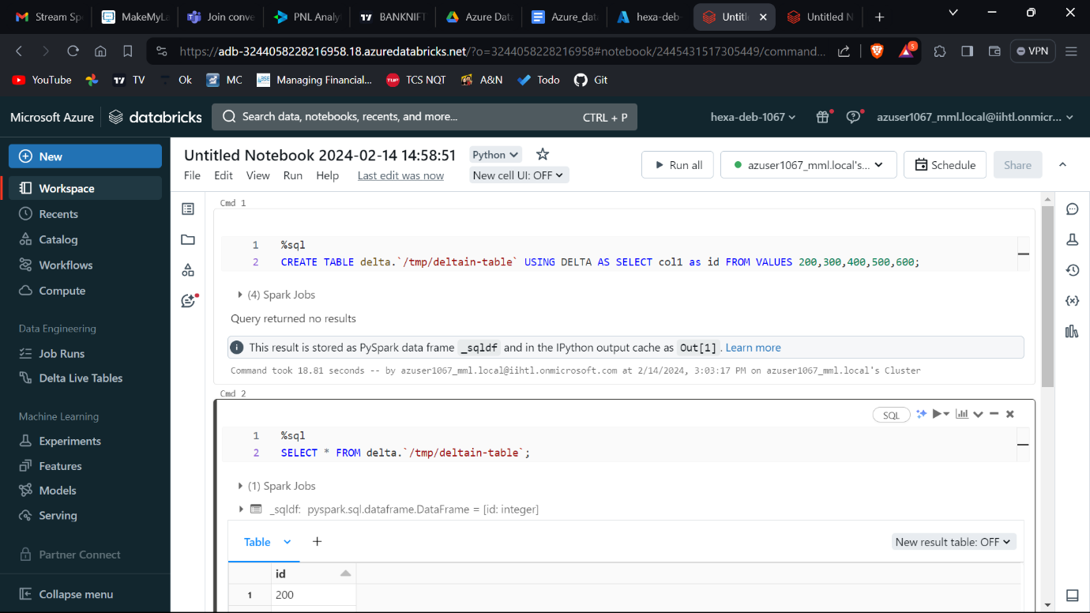

[Read data](https://docs.delta.io/latest/quick-start.html#id6)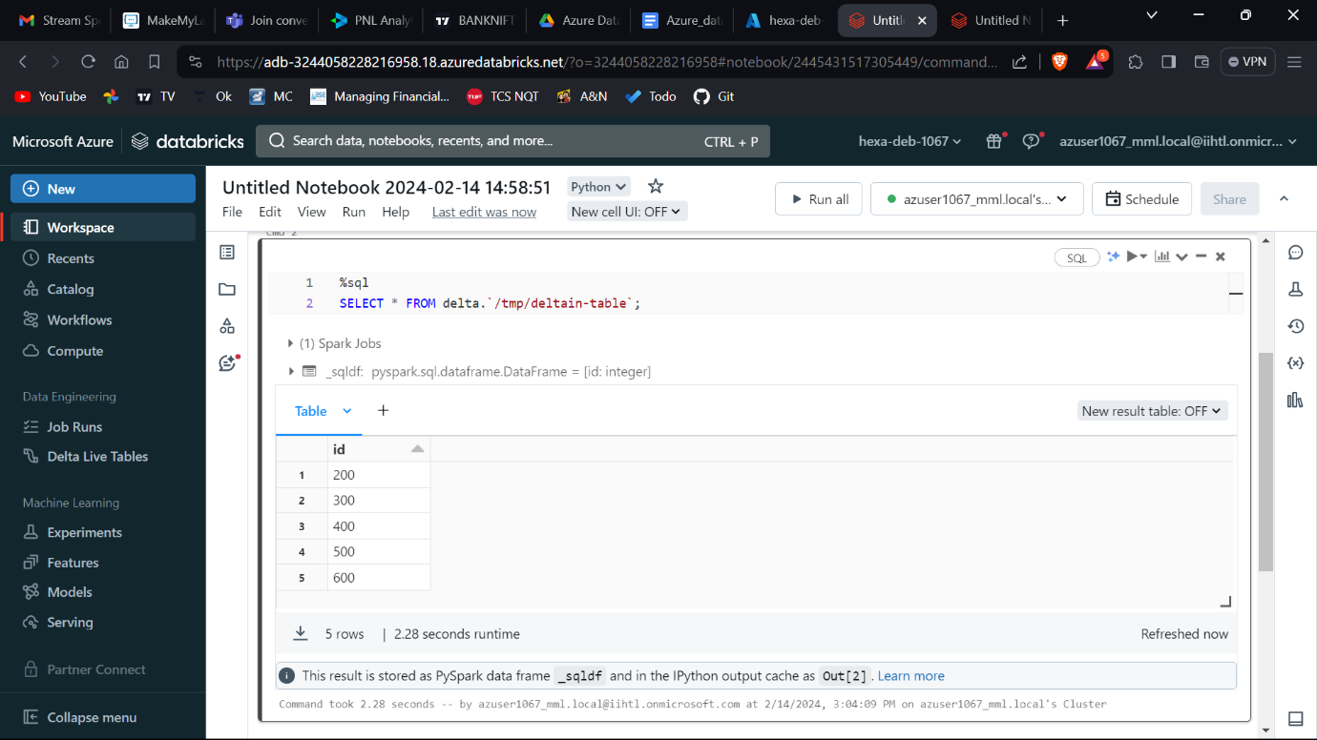

## [Update table data](https://docs.delta.io/latest/quick-start.html#id7)

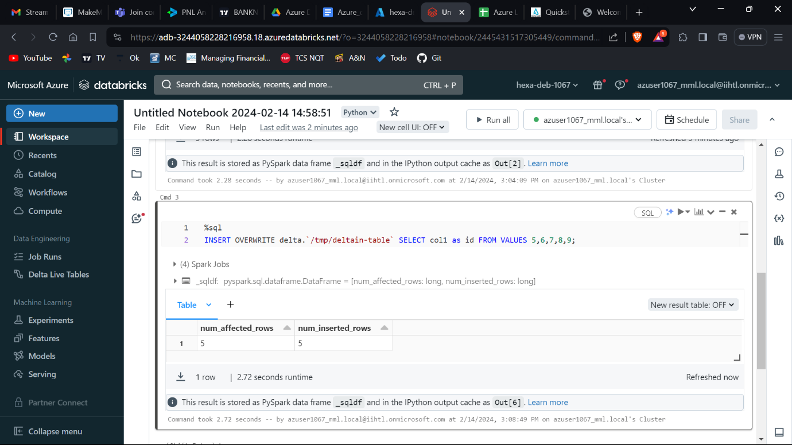

### [**Conditional update without overwrite**](https://docs.delta.io/latest/quick-start.html#id9)

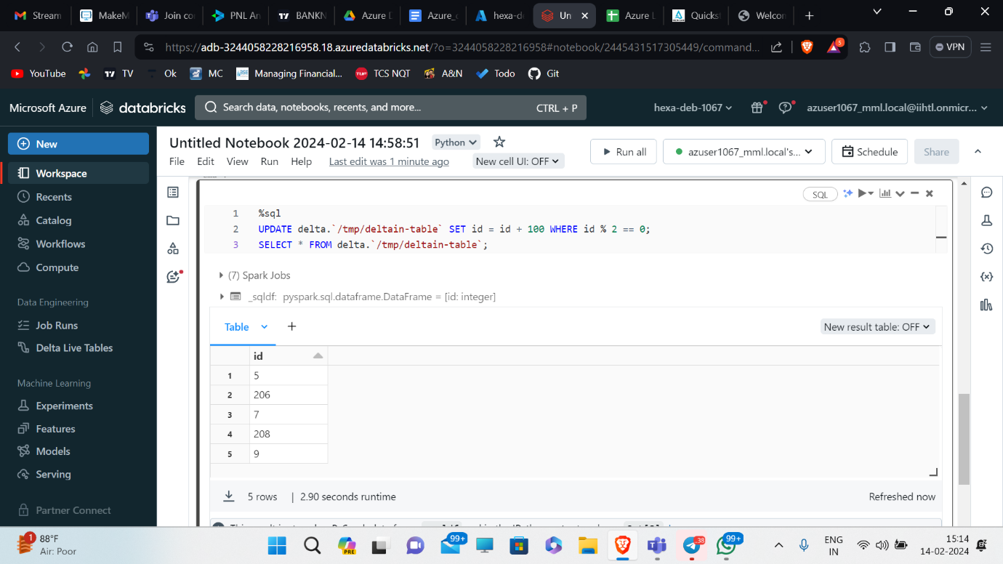

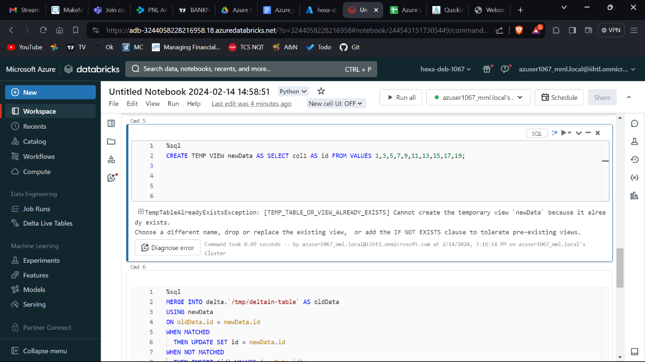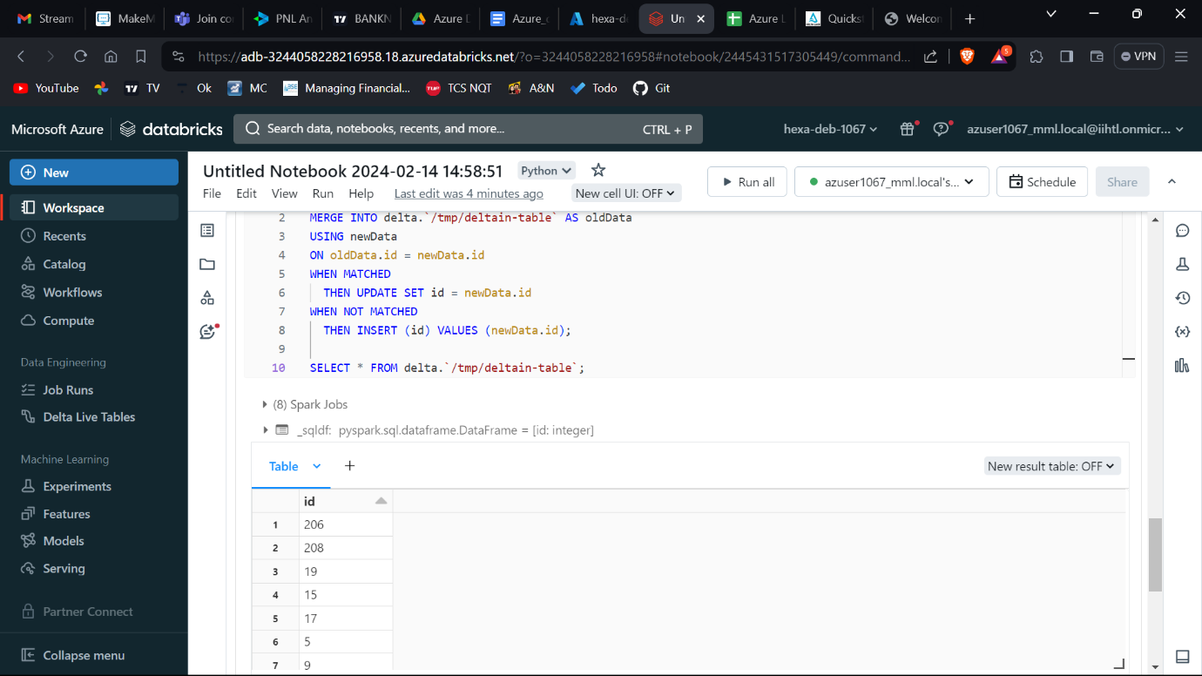

## [Read older versions of data using time travel](https://docs.delta.io/latest/quick-start.html#id10)

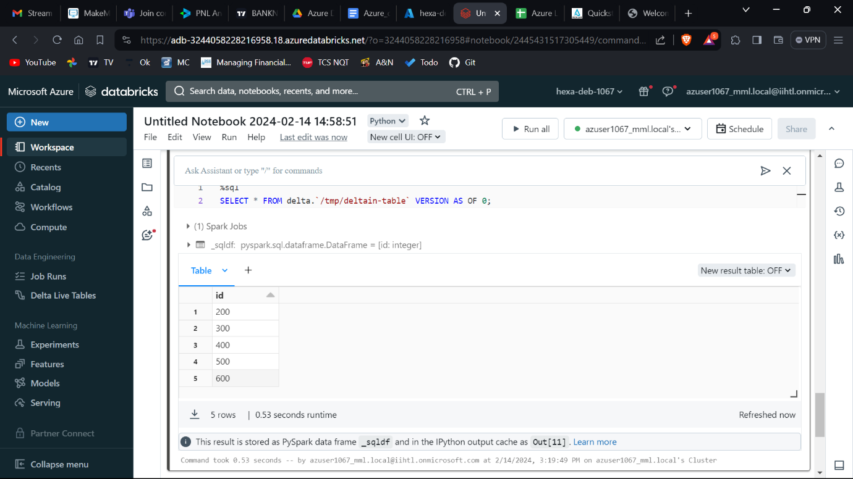

## [Write a stream of data to a table](https://docs.delta.io/latest/quick-start.html#id11)

